**Report Back on Phenology Model for Egg Development in Coregonids**

**International Coregonid Workshop, Thonon, France**

**14-15 March 2018**

**Date of document:** 31 March 2018

**Participants** (original sub-group meeting on 15 March)

Marek Šmejkal (Czech Academy of Sciences, Biology Centre, mareks1@centrum.cz); Matteo Zucchetta (Ca’ Foscari University Venice, matzuc@unive.it); Josef Wazenböck (Research Institute for Limnology Mondsee – University of Innsbruck, josef.wanzenboeck@uibk.ac.at); Ian Winfield (Centre for Ecology & Hydrology, ijw@ceh.ac.uk); Jason Stockwell (University of Vermont, jason.stockwell@uvm.edu)

**Additional Interested Participants?**

Jiri Peterka (Czech Academy of Sciences, Biology Centre, jpeterkacz@yahoo.com); Tomas Juza (Czech Academy of Sciences, Biology Centre, [tomas.juza@seznam.cz)](mailto:tomas.juza@seznam.cz)); Juha Karjalainen (University of Jyväskylä; juha.s.karjalainen@jyu.fi)

**Overall**

Develop a model to evaluate latitudinal differences in, and the potential impacts of changing thermal phenology (lake cooling in autumn/winter and warming in spring) on, the relationship between spawning date and hatching date at the scale of daily cohorts. One purpose of the model is to inform experimental design of temperature effects on egg incubation, and conversely, use results from experiments to better inform (refine) the model. An extension of the model could include growth of larvae to the end of the first growing season to relate phenology of spawning to first year growth (with implications for over-winter survival).

**Conceptual Model**

* Use daily water temperatures from autumn to spring from three “typical” coregonid lakes in north, central and south latitudes.
* Use typical start/stop temperatures for spawning times for populations in each of these typical lakes (latitudes). Eggs are deposited using a normal distribution (as a start). For an example, see Jones et al. (2003) which models spawning time, egg development, and hatching date for walleye (*Stizostedion vitreum*) at a daily time step.
* 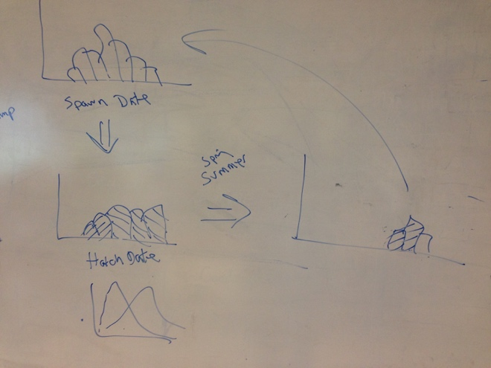Track degree days for each daily cohort of eggs until hatch date for each cohort (Figure 1 left side). Can introduce variation (random or other) in the accumulation of degree days if useful. Modeling of degree-day accumulation and time to hatch can be based on established models developed in Poland (Luczynski and Kirklewska 1984) and compared among Finnish, Polish and German coregonid populations (Karjalainen et al. 2016). Other models exist for North American species (e.g., Colby and Brook 1973; Brooke 1975), which might provide an additional interesting contrast (across species).
* Josef gave an overview of experiments that used different constant temperatures to measure time to hatch and the range of hatch times, suggesting warmer incubation temperatures decrease time to hatch and reduce the range in timing of hatch (see 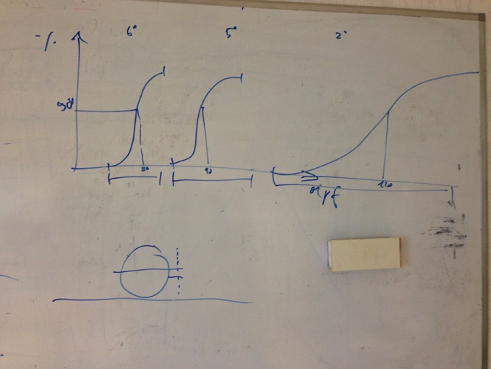Figure 2)
* Vary phenology of lake cooling and warming to explore how timing of spawning and hatching may vary among latitudes and climate change if spawning start and end temperatures remain static (or change).

**Initial Data Needs/Requests**

* Lake temperature data from zone of spawning in north, central, and south latitudes from autumn (prior to spawning) to spring (after hatch)
* Typical start and end spawning temperatures in north, central, and south from autumn (prior to spawning) to spring (after hatch)
* Typical start and end hatching temperature (dates) of larvae in north, central, and south from autumn (prior to spawning) to spring (after hatch)
* Have requested these data from Juha, Chloé, and Marek
* If/when we extend model to include first growing season, then we will likely need to identify and request data on such metrics as length-at-hatch, growth rate, etc., across latitudes and populations.

**Initial Tasks and Responsibilities**

* Jason to draft summary of discussion (this document) and send to Taylor and Emilien after receiving comments from modeling group
* Jason to request initial data (done on 15 March). Jason has followed up with a second email (March 31).
* Juha, Marek, and Chloé to provide initial data. Included Jiri Peterki as Marek is in the field for a few more weeks.
* Matteo and Marek will begin to think about model construct in R. Marek will talk to his colleague(s) who models.
* Jason will schedule video conference call within one month, assuming data from initial request are provided within that time frame, to discuss next steps.
* Suggest everyone read the papers listed in references as a starting point. These have been posted to the Slack site for the coregonid group under Modeling group.

**References**

Brooke, L.T. 1975. Effect of different constant incubation temperatures on egg survival and embryonic development in lake whitefish (*Coregonus clupeaformis*). Transactions of the American Fisheries Society 3:555-559.

Colby, P.J., and L.T. Brooke. 1973. Effects of temperature on embryonic development of lake herring (*Coregonus artedi*). Journal of the Fisheries Research Board of Canada 30:799-810.

Jones, M.L., J.K. Netto, J.D. Stockwell, and J.B. Mion. 2003. Does the potential benefit of creating access to new spawning habitat for walleye (*Stizostedion vitreum*) depend on its location relative to nursery habitats? Canadian Journal of Fisheries and Aquatic Sciences60:1527-1538.

Karjalainen, J., L. Jokinen, T. Keskinen, and T.J. Marjomäki. 2016. Environmental and genetic effects on larval hatching time in two coregonids. Hydrobiologia 780:135-143.

Luczynski, M., and A. Kirklewska, 1984. Dependence of *Coregonus albula* embryogenesis rate on the incubation temperature. Aquaculture 42:43–55.